**Global Supply Chain of Medical Equipment: Vulnerability Assessment, Emergency Response Tool, and Financial Impact Analysis**

**1. Specific Aim**

This proposal will enable the researchers to establish foundations for collaborative work and plan to apply for future funding opportunities within the 2020 calendar year. The aim of this collaborative project is three-fold: 1. Assess the vulnerability across the global supply chain of medical equipment, 2. Develop an emergency response tool, and 3. Measure the impact of change in global supply chains on firms’ financial performance.

**1.1 Vulnerability Assessment.** While researchers had warned that issues such as “90 percent of the latex for sterile gloves [being] produced in Malaysia” or “a significant portion of surgical hand instruments [being] manufactured in Pakistan” are concerning (MRB, 2016, as cited in NASEM, 2018 p. 10), however it was the COVID-19 that exposed the vulnerability of the global supply chains to policy-makers and the general public. Through this research we develop a network model of the global supply chain of medical equipment using a ten-tier supply chain network; comprising five tiers forward and five tiers backward. The Innovation & Entrepreneurship Business Ecosystem Lab (IBIE Lab) housed in North Carolina Central University’s School of Business has developed unique data mining capabilityies to develop such supply chain networks at the country-level, industry-level, and firm-level. Furthermore, we are capable of locating supply chain network nodes by state/province, city, and zip/postal code. Using multidisciplinary network-based modeling we will develop tools to measure supply chain vulnerabilities and fragmentations. In our pilot, we will provide the top countries and firms that can impose the highest interruption to the US global supply chain of medical equipment.

**1.2 Emergency Response Tool.** On March 27, 2020, the United States’ president “ordered General Motors Co. to … ramp up the production of ventilators”[1]. This was more than two months after the first case of COVID-19 was diagnosed in the United States (state of Washington).

Since time is of the essence in fighting pandemics, policymakers need to have access to tools that can instantaneously provide alternative supply chain paths in case of a disruption using multiple network layers. We will develop a rapid response supply chain interruption tool that is capable of identifying alternative supply chain paths in case of disruption in a region, a country, state/province, city, or a collection of firms. In this report, a network visualization of our feasibility study is presented where our algorithm was shown to be capable of correctly identifying auto manufacturing firms, as the only alternative to supply medical equipment when supply chains are ruptured in China (Figure 1). We propose to develop a pilot interface where the users can select certain firms or countries to be removed the global supply chain and our tool can dynamically present alternatives using networking algorithms (c.f. Figure 1).

**1.3 Financial Impact.** The third aim of this research is to explore the financial consequences of the change in the structure of the global supply chain network; a change that incorporates the elimination of a cluster of firms from the global supply chain networks. This work is focused on the “medical equipment” as a critical industry in response to COVID-19 and as the most likely industry to be subject to upcoming global protectionism policies. In our pilot study, we measure how firms are financially affected as a result of their position across several tiers of intertwined global supply chain pre- and post-elimination of a country from the global supply chain. Our pilot will include scenarios where several countries individually, or a collection of countries are ruptured from the global supply chain of medical equipment industry.

**2. Research Strategy**

**2.1 Motivation for Research**

The supply chain and logistics associated with emergency response and pandemics have been a subject of several studies over the past few decades. In geographically limited emergencies “logistics issues” especially as it relates to low-tech equipment such as Protective Personal Equipment (PPE) are “straight forward” as they can be “purchased inexpensively” and the main issue is the availability of “multiple size and type” of PPE (Willis, 2006, pp: 64). However, in the case of widespread natural disaster relief operations (such as COVID-19), including “catastrophic epidemic outbreak[s]” there exist explicit consensus in the literature that geographically expansive supply chain interruptions should be expected as a result of “disruption in the distribution and transportation” (Syahrir, Suparno and Vananyl, 2015) as well as manufacturing limits. Kumar and Havey (2013), Dasaklis, Pappis, and Rachaniotis (2012) and Peng, Peng, and Chen (2014) have made important contributions in this area. Syahrir et al. (2015) in their review of literature on health care and disaster supply chain have highlighted that most research in this area is focused on exploring supply chain in “normal operating conditions”, however, there is a gap in the literature on studying supply chains in “abnormal” situation, or what Ivanov (2020) refers to as “special” situations when he calls for research related to COVID-19. These abnormal or special cases –such as COVID 19– not only cause global supply chain disruptions but also cause suspension in manufacturing (Retaildive, 2020, as cited in Ivanov, 2020)

Syahrir et al. (2015) in their work on the “healthcare supply chain” describe that supply chains in the healthcare sector have certain complexities as they require timely procurement of various “medical needs such as medical equipment, medicines, anti-virus, vaccine, etc.” One of the characteristics of the medical equipment and medicine is that for certain raw materials, parts, and equipment across the tiers of supply chain few countries have an elevated, out-sized, role in maintaining the continuous functioning of the global supply chain. For example, “90 percent of the latex for sterile gloves is produced in Malaysia” and “a significant portion of surgical hand instruments are manufactured in Pakistan.” (MRB, 2016, as cited in NASEM, 2018 p. 10). In a business environment with high dependencies across borders the current intertwined global supply chain network is ripe to cause “serious repercussions worldwide” stemming “from any of the destabilizing factors known as the “four P’s: powerful weather, pandemic, port closures, and political instability” (NASEM, 2018, p. 10). The 2018 NASEM report on the global medical supply chain further explains the focus on operational efficiency programs such as implementing just in time inventory management. This report highlights that there is a gap in action. The COVID19 exposed a special risk of global supply chains; a risk with high magnitude, short-term as well as long-term consequences (Ivanov, 2020).

These developments motivated us to create a team of researchers from North Carolina Central University, UNC-Chapel Hill and Arizona State University to explore three aspects of the global supply chain of medical equipment, namely, vulnerability assessment, emergency response tool, and financial impact analysis. After discussing the current state of the global supply chain my? medical equipment and the interruptions imposed by COVID-19 a discussion of our proposed research project is presented along with a sample feasibility study.

**2.2 State of Global Supply Chain in the Medical Equipment Industry**

The global supply chain and production of medical equipment have experienced significant transformations over the past few decades. Jha (2019) describes four recent trends in the medical equipment domain which can further explain the vulnerability of the industry’s supply chain in global pandemics. The first trend is the separation of Original Equipment Manufacturers (OEMs) of the medical devices from sales, inventory management, and distribution of medical equipment. For example in the United States, Group Purchasing Organizations (GPOs) have control and power and control over distribution channels and activities. The second trend is the role of governments, which varies from one country to another. In many countries, governments enforce price caps and product standards in their market. The third trend is reduced brand differentiation as a result of increased similarity of quality and performance of devices manufactured by different manufacturers in developing countries. For example, a device manufactured in India by MNCs according to Jha (2019) has comparable performance to one manufactured in more complex and technologically advanced facilities. Finally, the use of advanced supply chain management and private equity firms has further standardized and consolidated the industry at the global level.

The~~se~~ very same trends which were celebrated up until 2019 (c.f. Jha, 2019), have now become points of concern and contention for individuals, firms, and governments around the world. A recent survey from National Association of Manufacturers (NAM) conducted in early 2020 (NAM report, 2020) from US manufacturers revealed 35% respondents reported facing supply chain disruptions as early as February/March of 2020, while 53% reported expecting changes in their operations as a result of COVID19. 78% of respondents reported uncertainty about the financial impact of supply chain disruption on their business; this latter information highlights the magnitude of interruptions on the business environment. While this research is being conducted in the early months of this pandemic, future research can provide a far more comprehensive assessment of the scope and magnitude of the supply chain disruption at the national and global scale.

**2.3 COVID-19 and the Global Supply Chain of Medical Equipment**

Ivanov (2020) describes three reasons why epidemic outbreaks are special cases of supply chain risk. These reasons are uncertainty about scale and duration of the disruption, ripple effects of disruption among people and supply chain actors, and disruption in operational infrastructure (Ivanov, 2020). Unlike the other pandemics of the past including Ebola, MERS, and SARS, the COVID-19 is more likely to impose long-term, far-reaching, changes to global supply chains as a result of “rising protectionism” and the upcoming “global financial crisis” (Salvatore, 2020). Javaid, Haleem, Vaishya, Bahl, Suman, and Vaishin (2020) their study on the fourth industrial revolution (Industry 4.0) and medical equipment manufacturing, provided evidence that even before the recent pandemic there had been explicit interests and actions toward reshoring manufacturing. The advancements in redistributed manufacturing (Hannibal and Knight, 2018) can further facilitate the localization of manufacturing in a post-COVID19 political and business environment.

The root of vulnerability in the medical equipment supply chain originated before the 2019 epidemic. In addition to the global nature of supply chains (Ivanov, 2020), Shokrani, Loukaides, Elias, and Lunt (2020) argue that two other factors have contributed to the vulnerability of the global supply chain of medical equipment “due to the global coronavirus (COVID) pandemics”. The first factor is that the manufacturing of medical equipment in advanced economies have become more “focused on manufacturing low-volume, high-value, [and] high-margin products” over the past few decades. The second factor contributing to the increased supply chain vulnerability to such interruptions is the dominant supply chain management practices promoting leanness and high-volume efficiency across the global supply chains.

**2.4 Data Collection and Analysis**

We use S&P Global Market Intelligence to have access to financial records of the firms. S&P Global Market Intelligence provides access to various financial, industrial, geographical and operational data about firms. Additionally, we will use our unique data mining techniques to develop the global supply chain of firms in the medical equipment sector. We will use various network analytics algorithms and econometrics tools to achieve our aims. Figure 1 displays our feasibility study simulation of a major disruption to the global supply chain. This is the network of the global supply chain of medical equipment at the industry-level. The figure on the left displays the global supply chain before an interruption. The figure on the right illustrates the effect of removing all Chinese industries from the network. The result indicates that in response to such disruption only the “motor vehicle and car bodies” sector can revive the supply chain in the short-term. As mentioned previously our simulation correctly predicted an alternative supply chain path that was mandated in the United States in 2020 to address the need for ventilators.

Figure 1: Medical Equipment Supply Chain Industries: With and Without China[2]

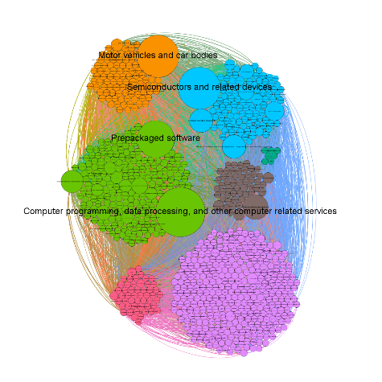 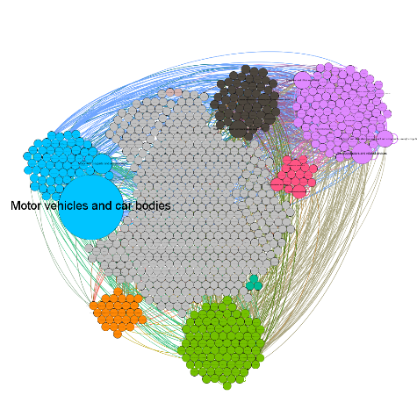

All countries All countries except China

**3. Budget**

|  |  |
| --- | --- |
| The main cost associated with this project is access to the financial database. We use proprietary data from S&P Global Market Intelligence (S&P Global). This database will be made available to all faculty. While this data is not publically available we still require to perform a significant amount of computation to mine the supply chain network data. Hence, we also require computers capable of computing large and complex networks.  We also allocated a budget for travel to attend conferences and/or workshops; considering the COVID-19 the budget may be used to attend virtual conferences/workshops. As the field of network analytics is a new area we require to hire highly skilled consultants for designing optimization models, and new algorithms. We have support from top-notch researchers in the areas of network science and supply chain at UNC-Chapel Hill and Arizona State University to support us in this endeavor. We have also added budgets for books, a website that displays our pilot projects, and any required cloud services. | $ 44,000 S&P Global  $ 12,000 Supplies (hard/software)  $ 7,000 Travel  $ 6,000 Consulting  $ 3,000 STATA  $ 2,000 Books, website, cloud  service  $74,000 Total |

**5. References**

**Attachments**

**NIH Biosketches**

**Letters of Support**

**References**

1. Wall Street Journal, Trump Orders General Motors to Make Ventilators, March 27, 2020.
2. The node colors identify clusters in the supply chain network. The node sizes illustrate eigenvector centrality.